PROPPED AND FIXED BEAMS
The minimum number of support reaction required to keep the beam in equilibrium = 2
Redundant Reaction: The non-essential support reactions on the beam to keep the object in equilibrium.
No. of Redundant Reaction = Statically Indeterminacy = Compatibility Equations
Finding Support Reactions
S. D. B | S. I. B
Equilibrium Equations | Equilibrium Equations + Compatibility Equations (Relation between Deflections)
2 Useful Equations  ∑ M = 0  ∑ Fy = 0 | Compatibility Equations = No. of Reaction – Useful No. Equilibrium Equations  = R – E
Syllabus says only Support Reactions (Force and Moments).
Propped Cantilever Beam | Fixed-Fixed Beam | Continuous Beam
A beam with fixed support at one end and roller support at another end | A beam with Both fixed end support | More than 2 support
Statically Indeterminacy = 1 | Statically Indeterminacy = 2 | Statically Indeterminacy = 1
In the syllabus | Not In the GATE syllabus | Only Symmetric loading in the syllabus
Use Method of super position and deflection at support (will be zero = Compatibility equation).
M_{A} = – M₀/2  R_{Prope} = R_{Support} = [ ∑ Moments] / L  = R_{A}  = – (3/2) (M₀/L)  = – R_{B} | 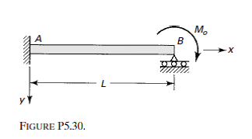
Analysis of Internal Hinge Problem:
Deflection at hinge in connected beam will be same.
- If beam is symmetric about hinge and 2) if the load acting at hinge, the beam can be divided into two parts at hinge and apply half of the load on each part of the beam.
Rigid Prop | Elastic Prop
δprop = 0 | δload – δreaction = δspring/gap and take moment about pivot

Continuous Beam analysis: Use Rigid/Elastic prop concept and find deflection at mid-point.

